LAB ASSIGNMENTS 3: What is Amazon S3?

Simple Storage Service is a scalable and secure cloud storage service provided by Amazon Web Services (AWS).
It allows you to store and retrieve any amount of data from anywhere on the web.

Instruction:
1. Explore option with S3 bucket creation
2. create a bucket to put data and apply versioning over it
3. Explore S3 bucket policies
4. Write Spring boot application to intract with S3
5. Install AWS CLI and create and access s3 from your terminal

USING AWS CLI

- Creating access token for IAM user

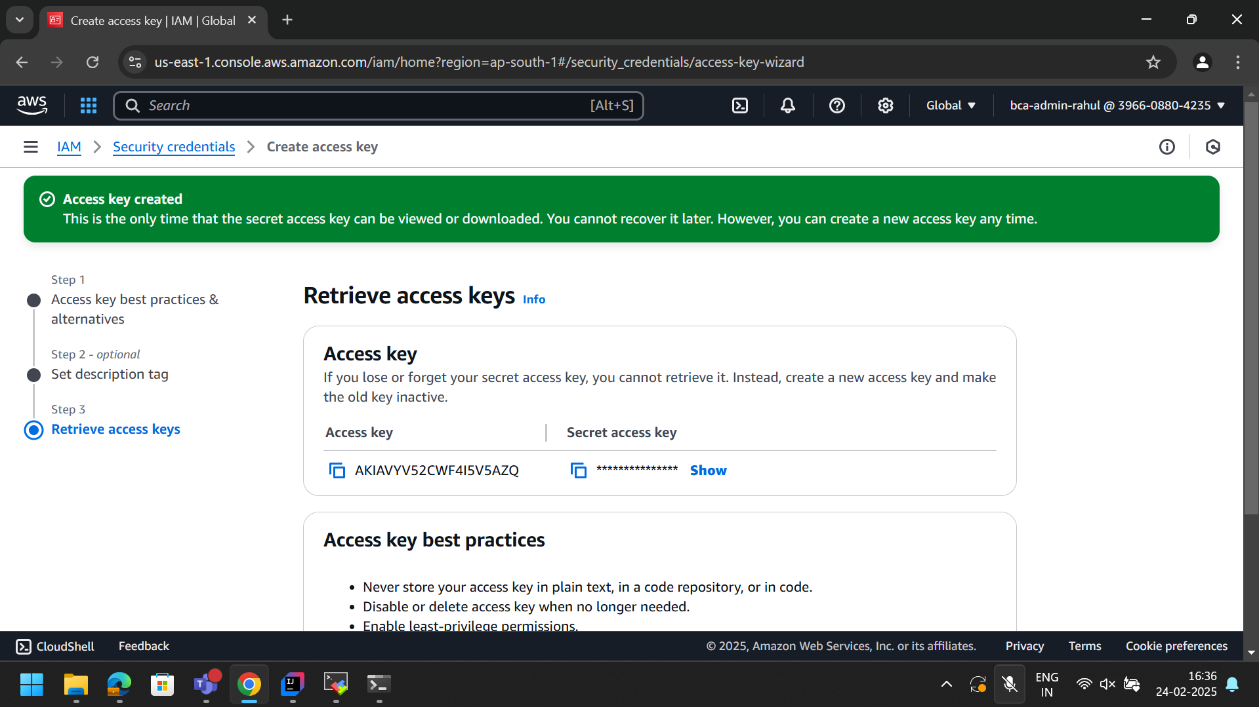

2.Use that token to configure cli and create bucket

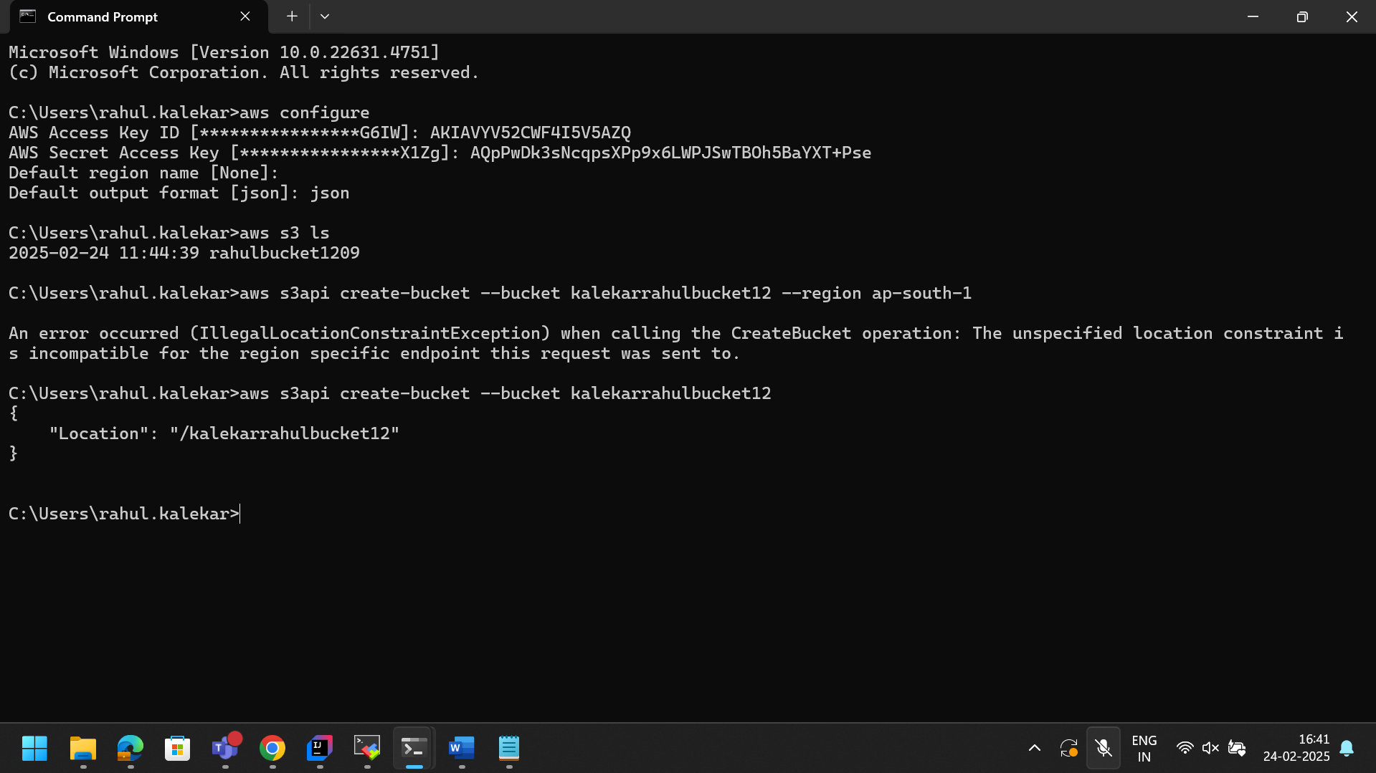

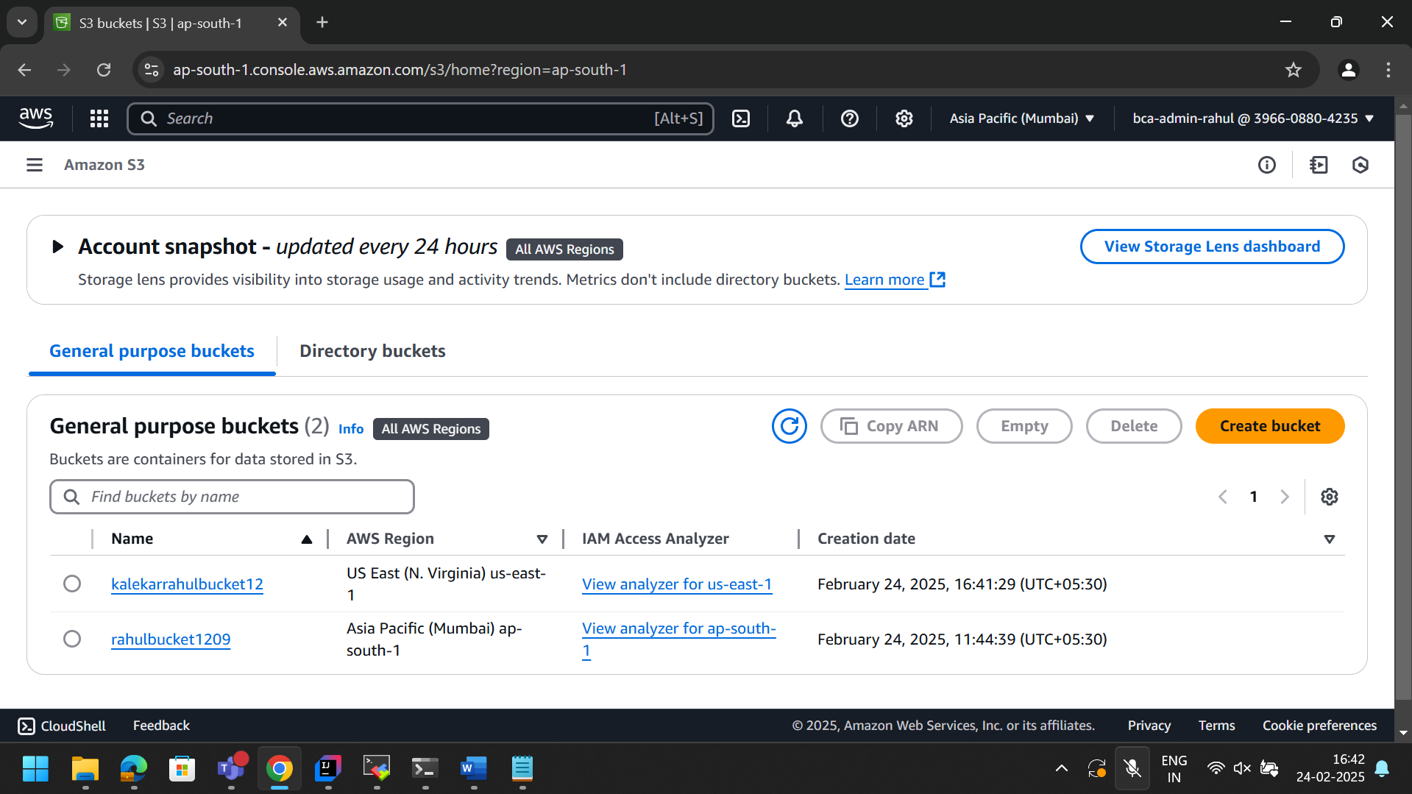

VERSIONING
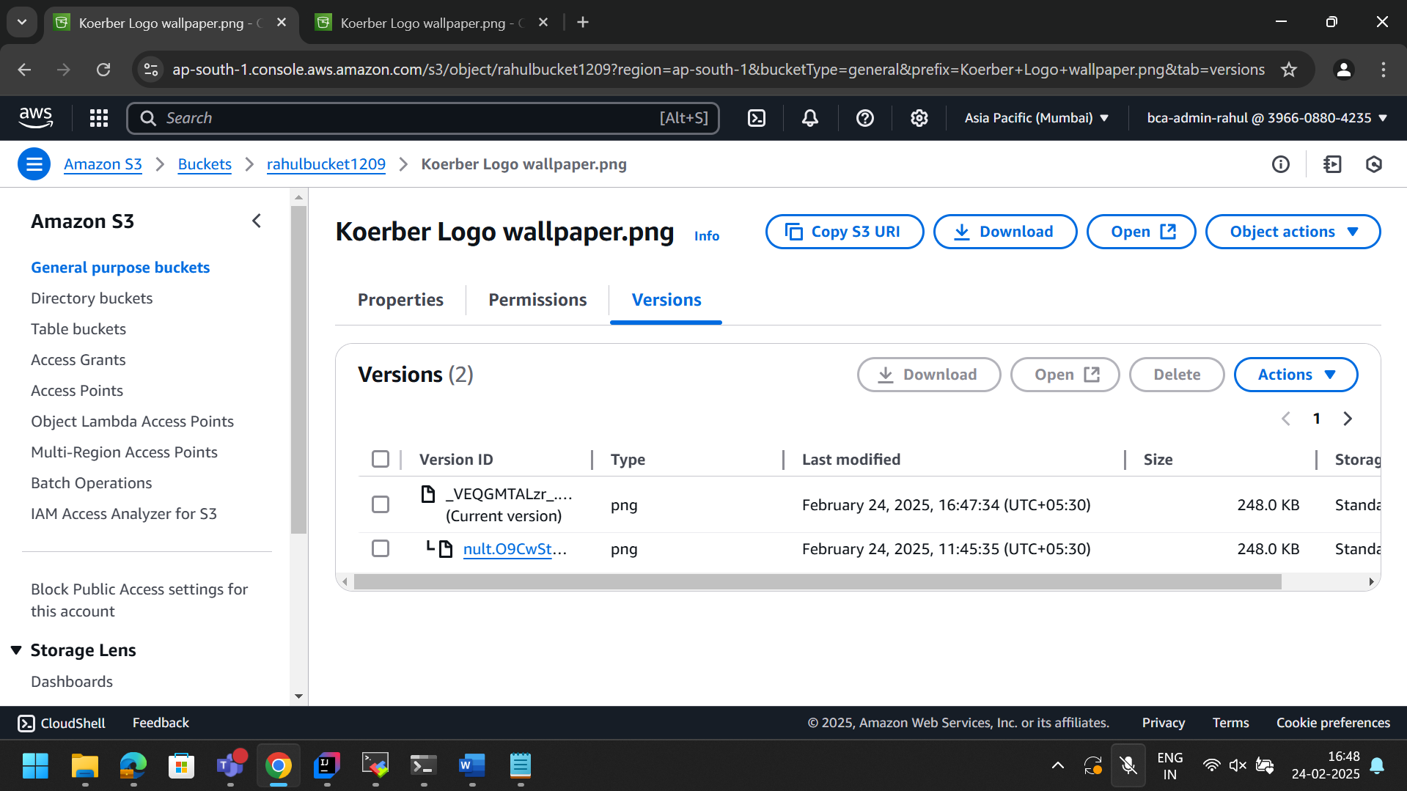

S3 BUCKET POLICY

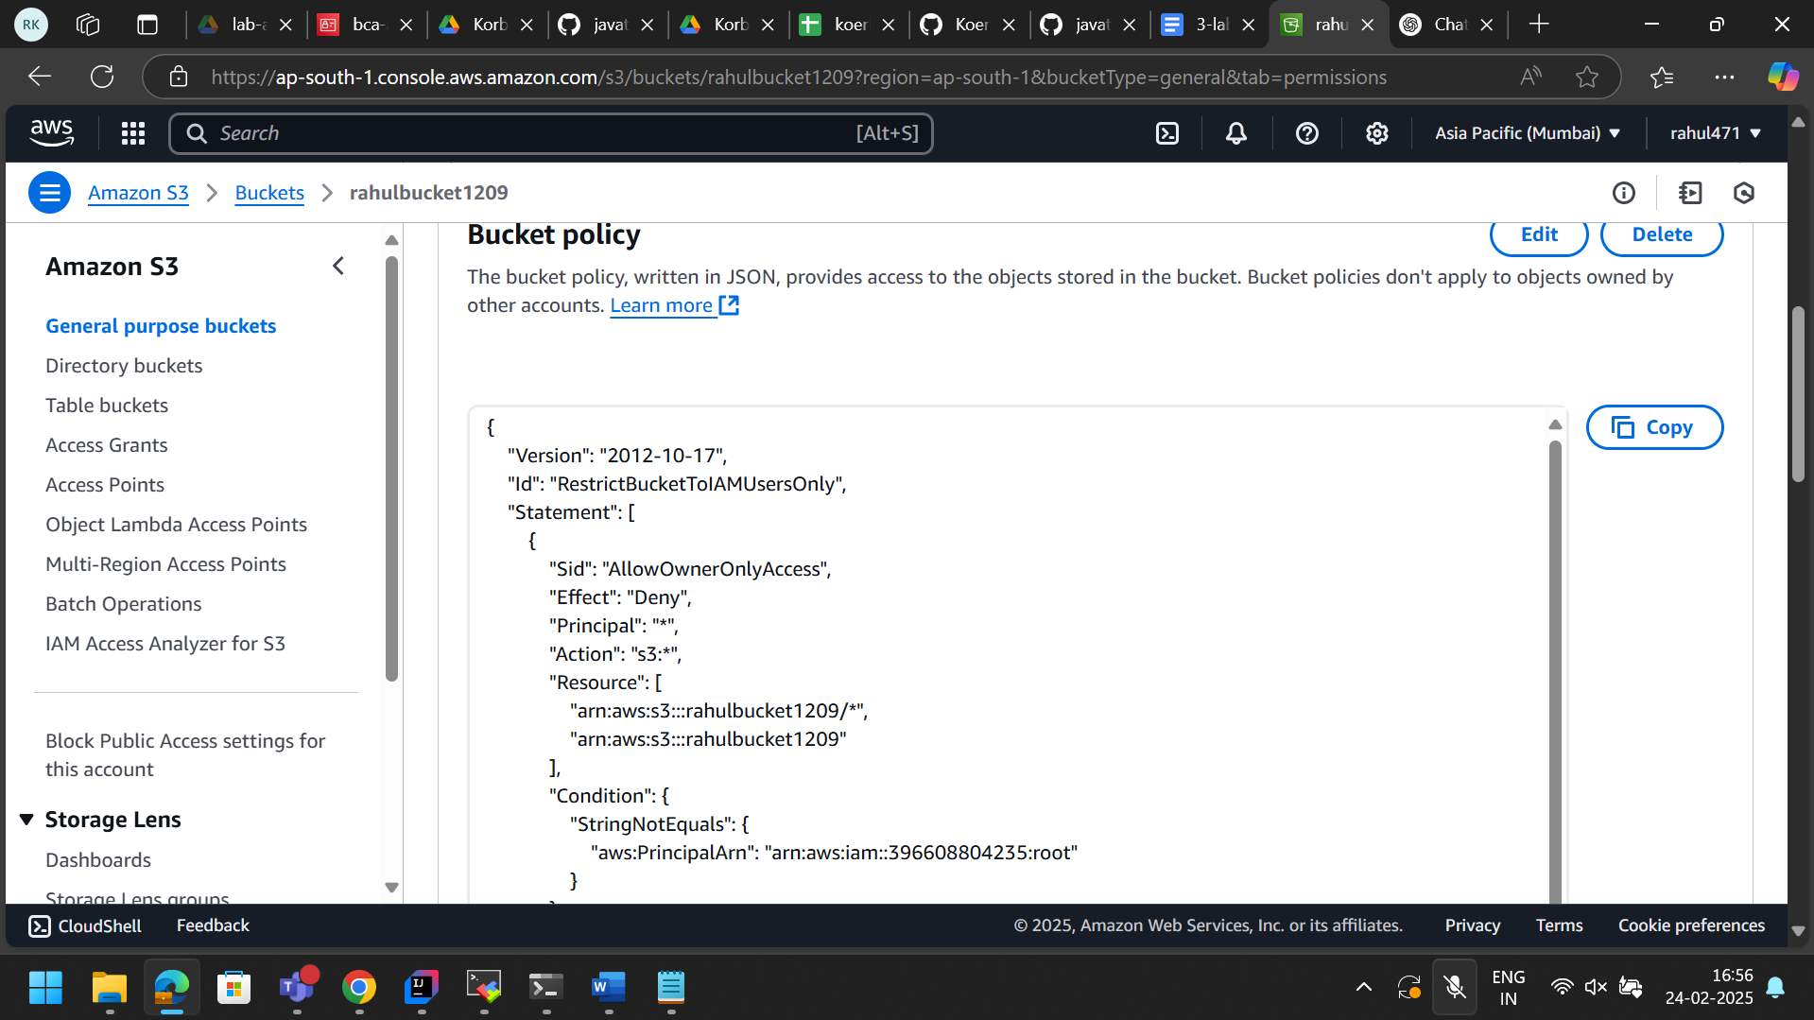

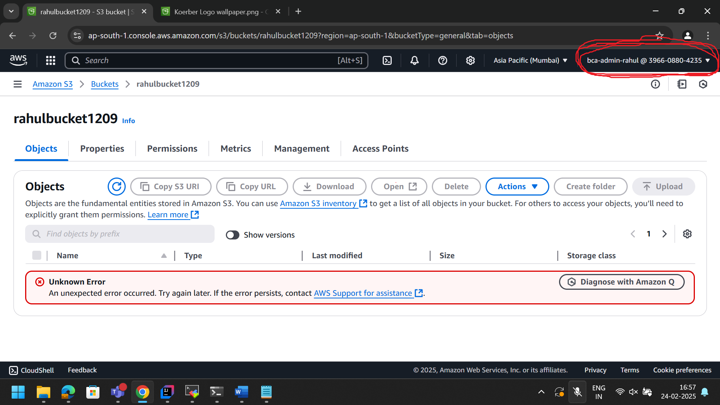

USING SPRING BOOT APPLICATION

